BUCKETS FOR BENEFIT

Buckets for Benefit is a program designed to help organizations raise money by selling premium laundry detergent, fabric softener, dish soap and other products. Organizations that team up with Buckets For Benefit make a profit while providing a product used in every household, daily.

In this overview you will find information about how our program operates. Your organization will sell our proven, best-selling products retaining a profit

Products
Detergents (5 gallons approx. 300-500 loads per bucket)
- Original Scent *equivalent to Tide Original
- Calm and Clear *equivalent to Tide Free and Gentle
- Original Breeze Scent *equivalent to Tide plus Febreze
- Original Spring Dew Scent *equivalent to Tide plus a touch of Downy
- Original with Bleach *equivalent to Tide Bleach Alternative
- Green Original Scent *equivalent to Gain Original
- Green Mango Passion Scent *equivalent to Gain Apple Mango Tango

Fabric Softener (5 gallons approx. 300-500 loads per bucket)
- Spring Dew Fabric Softener *equivalent to Downy April Fresh
- Green Island Tropics Fabric Softener *equivalent to Gain Island Fresh

Dish Soap (5 gallons and 1 gallon available)
- Sparkly Dish Soap (blue) *equivalent to Dawn
Pods (150 count)
- Original scent *equivalent to Tide Pods
- Calm and Clear *equivalent to Tide Free and Gentle
- Dishwashing Pods *equivalent to Cascade
Bath Bundle (includes the following products below)
- One 8oz body glaze lotion (scent may vary)
- One 8oz body polish sugar scrub (scent may vary)
- Six Fizzy Bath Bombs (scents may vary)
- Two Loofah Soaps (scents may vary)

Hair and Skin (1 gallon)
- Salon Style Shampoo *equivalent to Pantene
- Salon Style Conditioner *equivalent to Pantene
- Men’s Body Wash *equivalent to Axe
- Women’s Body Wash *equivalent to Victoria’s Secret

Dryer Sheets (3 boxes of 80 count)
- Green Island Tropics *equivalent to Gain Island Fresh
- Outdoor Breeze * equivalent to Bounce Outdoor Fresh

Fizzy Bath Bombs (12 count of approximately 5oz bath bombs)
- Assorted scents
- Each 5 gallon bucket is manufacturer sealed and includes a pump. *As of 9/17/19 1-gallon containers will no longer include a pump.
- Each order of Pods is manufacturer packed.
- Long stem 5 gallon pail pumps.
- All products are manufacturer packed and sealed. All weights, ounces, counts and measurements are approximate and are subject to change without notice. Items are not being sold as Proctor and Gamble products, Unilever products, Sun Corporation or Victoria’s Secret products. Tide, Tide Free and Gentle, Tide plus Febreze, Tide plus a Touch of Downy, Tide Bleach Alternative, Gain, Gain Apple Mango Tango, Gain Island Fresh, Downy April Fresh, Dawn, Cascade, Pantene, Axe, Bounce Outdoor Fresh, Snuggle Blue Iris, Snuggle Wild Orchid and Victoria’s Secret, Dove, Garnier are registered Trademarks. All rights reserved.
Pricing, Profit and Payment
- Buckets for Benefit has the exclusive right to provide all 5 gallon buckets and all other products for this program (the “Organization”) will purchase the buckets and all other products from Buckets for Benefit that are sold to consumers.
- All premium buckets will be sold for $45 by the Organization, which includes a pump, all bath bundle buckets will be sold for $45, all pods will be sold for $35, all 1-gallons will be sold for $25, and all dryer sheets will be sold for $16. The Organization may not offer the products to be sold at any other price, whether higher or lower.
- The Organization will pay Buckets for Benefit $32 for each premium 5 gallon bucket for the first 299 buckets (profit for first 299 is $13 the difference between $45 sale price and $32 purchase price) sold.
- The Organization will pay Buckets for Benefit $31 for each premium 5 gallon bucket for 300 or more buckets (300th plus bucket profit is $14 the difference between $45 sale price and
$31 purchase price) sold.
- The Organization will pay Buckets for Benefit $35 for each Bath Bundle Bucket sold (includes 1-8oz body glaze lotion, 1-8oz body polish sugar scrub, 6 fizzy bath bombs and 2 loofah soaps. The Organization will retain $10 profit per Bath Bundle Bucket (the difference between $45 sale price and $35 purchase price) sold .
- The Organization will pay Buckets for Benefit $30 per individual sale for all pods (laundry 150 count, dishwashing 150 assorted). The Organization will retain
$5 per individual sale for all pods (laundry 150 count and dishwashing 150; the difference between $35 sale price and $30 purchase price).
- The Organization will pay Buckets for Benefit $20 for each 1 gallon sold. The Organization will retain $5 for each 1 gallon (the difference between $25 sale price and $20 purchase price) sold.
- The Organization will pay Buckets for Benefit $11 for 3 boxes of 80 count dryer sheets. The Organization will retain $5 for 3 boxes of 80 count dryer sheets (the difference between $16 sale price and $11 purchase price). Dryer sheets cannot be sold separately. Three boxes per order will be the same type, no mixing allowed.
- If the Organization achieves free shipping, cash awards will be granted to the first, second and third place sellers for the Organization (1st = $100, 2nd = $50, 3rd = $25). The Organization is responsible for asking/telling Buckets for Benefit that they want/have achieved the cash incentives. If Buckets for Benefit is not notified by the organization prior to receiving an invoice, the cash incentives may be void.

- Mega Incentives are determined between Buckets for Benefit and the Organization per verbal agreement.
- The Organization will be responsible for collecting, counting and handling all money. Buckets for Benefit is not responsible for any money collected/raised by the Organization. All checks received from consumers for all products will be payable to the Organization and not to Buckets for Benefit.
- All payments for products (5 gallons, pods,1 gallons, bath bundle bucket, dryer sheets and bath bombs) will be paid to Buckets for Benefit in the form of a lump sum by Organization. Tax not included in any of the above pricing. Tax does not apply to Organizations that provide a tax exemption number/form. Any and all taxes due are the sole responsibility of the Organization. If the Organization is not tax exempt they will be charged sales tax at 8.225% (percentage may change without notice).
- Buckets for Benefit accepts checks, money orders and cashier’s check as form of payment from the Organization. Purchase orders and personal checks are not accepted. There will be a service charge of $100 on any returned checks. Please allow 1-2 weeks for processing of payment.
- Payment to Buckets for Benefit is required before the buckets and/or products will be delivered. Once Buckets for Benefit has received has cleared and processed completely, products will be delivered to a set location (please allow 1-3 weeks for processing; subject to change).
- A cancellation fee of up to $250 will be applied to all organizations who fail to complete a fundraiser after order forms have been created and/or mailed. If professionally printed order forms were created and shipped, those will be added to the cancellation fee.
Order Forms and Placing Final Order
- Order forms will be emailed at no cost to the Organization and will be personalized according to the program (view sample order form at www.bucketsforbenefit.com; sample may be different than actual form depending on product changes/pricing). This includes adding the sales periods the Organization plans to sell within. The Organization will determine the sales period for the set program (beginning sales date and ending sales date). Extending the sales period will change delivery and pick-up date for consumers.
- Any and all order forms made by Buckets for Benefit for an organization initiating a fundraiser and who has agreed to the program guidelines via the contact information form on the website www.bucketsforbenefit.com can only be used as part of a fundraiser conducted through Buckets for Benefit. Using an order form created by Buckets for Benefit in conjunction with another fundraising company is STRICTLY prohibited and will result in a
$250 customization/handling fee. We reserve all rights to any order forms and produced for an organization.
- Professionally printed order forms (optional) can be ordered by the Organization from Buckets for Benefit. These order forms are printed on a cardstock type paper and will be shipped to the address provided on the Order Form Information and Sign-Up page. Professionally printed order forms are not free and will require payment at the end of the fundraiser. The total for order forms/shipping will be deducted on the final invoice. If the Organization reaches their free shipping goal, the professionally printed order forms will be free. Order form prices may vary and are subject to change (usually run $0.30-$0.40 each). If the Organization chooses to have order forms printed/shipped, please allow extra time for processing and shipping.
- Organization will be responsible for determining a number of professionally printed order forms before sales period begins. There will be a $2.00 plus shipping charge per order form for any additional order forms printed.
- Organization maybe be required to provide secured terms of payment for professionally printed order forms such as credit, debit or other agreed upon payment.

- Organization is responsible for distributing order forms, keeping track of orders, collecting payment and returning the final order to Buckets for Benefit. Buckets for Benefit will not be responsible for lost or stolen money/order forms. It is the Organization’s responsibility to make sure each order form is turned in by the set date and are all accounted for. Please double check all order forms before turning in the final order.
- Once sales ending period nears, a final distribution spreadsheet (optional) will be provided to the Organization by Buckets for Benefit. However, the Organization may choose to turn in final order however they so choose (word document, excel spreadsheet, picture, etc). It is the Organization’s responsibility to make sure the final order is accurate, completed and turned in on the set date. Buckets for Benefit is not responsible for mistakes made by the Organization on the final distribution spreadsheet/final order.
- After the fundraiser deadline has been reached, it is the Organization’s responsibility to notify Buckets for Benefit of the number of buckets and/or products that need to be ordered and if they have achieved the cash incentives. At this time, Buckets for Benefit will then send an invoice to the Organization stating number of buckets and/or products, shipping cost (if free shipping goal is not met), tax (if applicable), cash incentives and payment due to Buckets for Benefit. Buckets and/or products will not be delivered until payment is received and cleared from Organization.
- Minimum of a 50 5-gallon bucket order is required per individual fundraiser in order to qualify for the shipping rates specified in the Free Shipping By State Guide . No other products can be combined to meet this minimum, strictly 5-gallon buckets only. If the minimum is not met,
a surcharge may be implemented depending on distance from a distribution center, quantity sold, shipping cost or other.
- After the final spreadsheet has begun processing, no other corrections/ additional spreadsheets will be accepted.
- Once the organization has been invoiced, no other orders may be corrected or added to the order.
Shipping, Delivery and Returns
- Free shipping is offered to Organizations that sell the minimum dollar amount of products listed on the Free Shipping Guide (see Free Shipping Guide below). The total sales amount is how much the organization must pay after profit has been deducted. If that sales minimum dollar amount is not met, shipping rates apply. These shipping rates are subject to change without notice. Organizations that sell less than 75 5-gal buckets during the said fundraiser may be subject to extra shipping costs. Final sales that result in selling less than the minimum dollar amount will require an additional shipping charge (subject to change without notice). Free shipping requirement updates effective for organizations registered on or after 3/8/21.
- All shipping quotes/charges are approximations for shipping to commercial locations and depend on weight/quantity. Residential locations may require an additional shipping charge and are not always guaranteed. All shipping quotes/prices are subject to change.
- Any and all substantial orders will need to be shipped to a commercial address only.
- Shipping charge must be paid before buckets will be ordered. Allow up to 3 weeks for delivery (this may be extended without notice). Free shipping goals are subject to change and will vary per state. x
- Shipping dates may change and could take longer than expected.
- A set date and location will be determined for products to be delivered to Organization (dates may be subject to change). Delivery dates are not chosen by the Organization. We can usually accommodate delivery requests but delivery dates can be subject to change. We do not always have control of delivery schedules.
- Some orders may be combined if the locations are close. This decision is made by Buckets for Benefit and could extend time for delivery.
- Pick-up times for the Organization’s consumers may not be held during time of delivery.
- 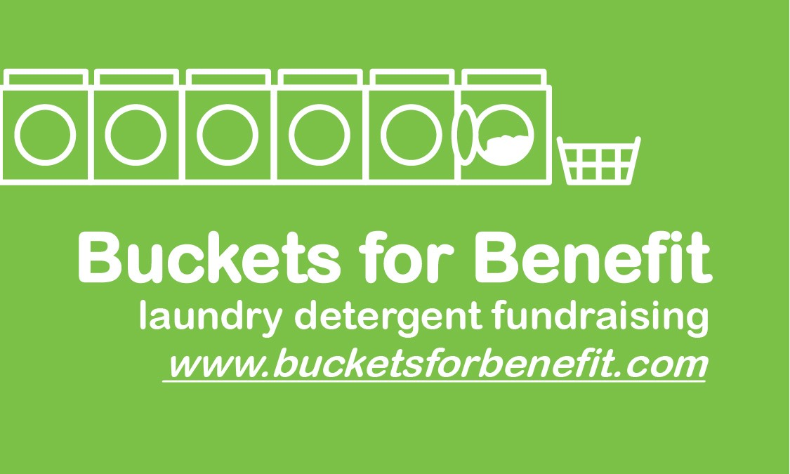All orders must be inventoried by a Buckets for Benefit employee with the Organization’s representative (responsible party). A representative of the Organization must be present at time of delivery. If no one is present, orders will be left at location provided on the Order From

Information and Sign-Up page. Buckets for Benefit will not be responsible for products after
they have been delivered to the organization.
• The Organization is responsible for the unloading of all products.
• After unloading is complete, an itemized inventory of all products must be taken. If a Buckets for Benefit representative is available they will go over that with you. If a Buckets for Benefit representative is NOT available, an inventory form must be completed and sent by email (info@bucketforbenefit.com) or text (618-727-0488). This must be done immediately after delivery and BEFORE any products are distributed to your customers. Buckets for Benefit must received the inventory form within 3 hours of delivery. This form will be attached to the delivery email. You may also access it here.
• The delivery driver is not responsible for unloading any products. If no one is available to unload, your organization may be subject to an idle and/or handling fee which must be paid before any products are unloaded.
• All products are guaranteed against manufacturer defects. Buckets for Benefit guarantees products 100%. Unsatisfactory products will be replaced at Buckets For Benefit’s discretion after review of consumer’s complaint. Buckets for Benefit is not responsible for any and all shipping costs or tax associated with any returns or exchanges of products. If a refund is issued, the profit paid to the organization is not refundable.

Any and all information within these guidelines is subject to change without notice. All customers/ consumers assume all responsibilities/liabilities while using any said products purchased from any and all events by which Buckets for Benefit provides goods and/or products/services. Buckets for Benefit has the right to refuse sales/service at any given time.

